**Architecture Diagram:**

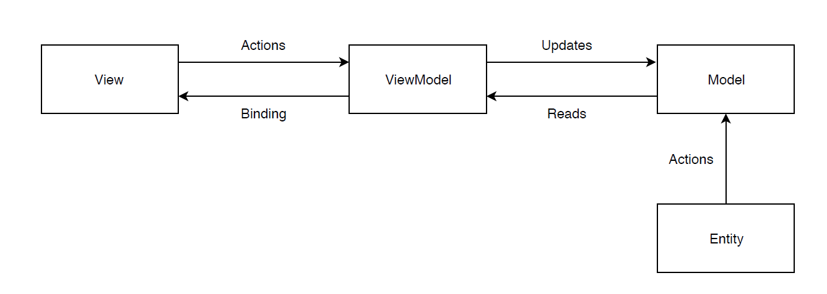

**UI Flow Diagram:**

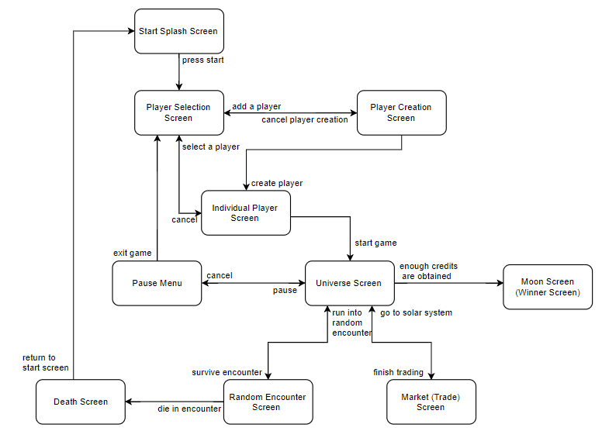

**GitHub Repo Link**: <https://github.com/CBushnell/BigBobaBrand>